Travaux Pratiques(DW)

## Atelier 4 : Intégration (Talend) & Reporting (Qlik View)

Annassiri Fatima Zahra _ BISD2_2020

**Etape 1 : Création du modèle en étoile dans la base**

In this step we create the database and the model of tables inside it, we get the result below :

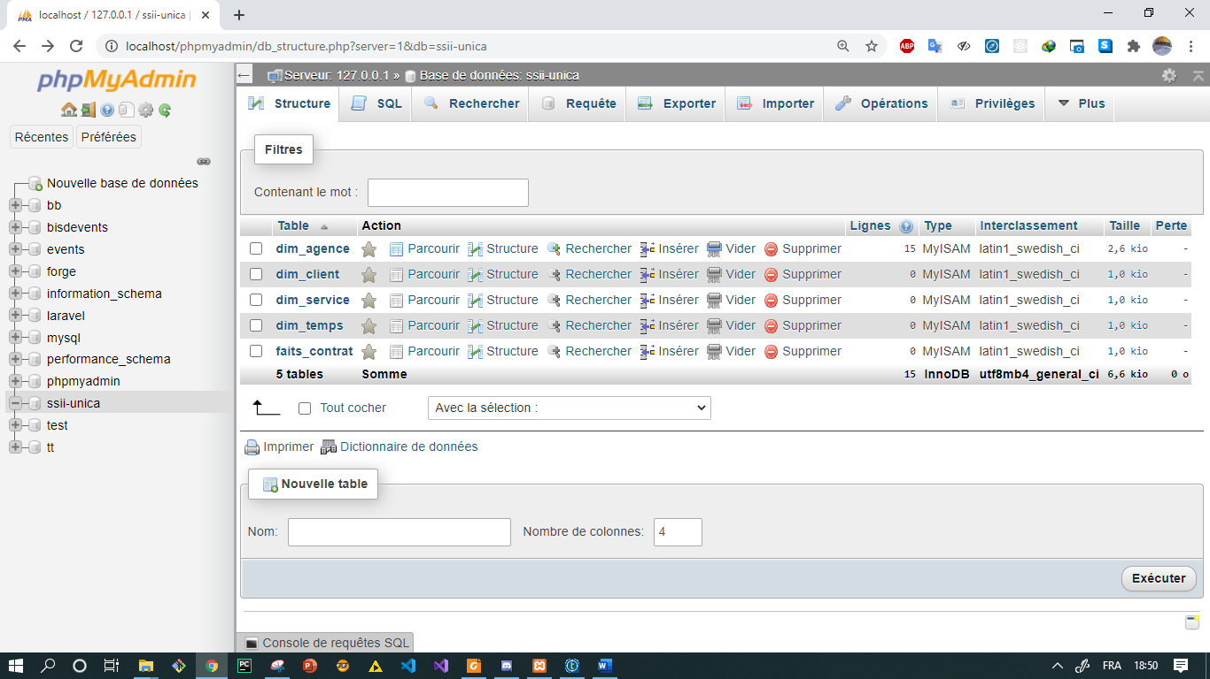

**Etape 2 :**

In this step we install the talend open studio tool and we create a new project with the option java.

**Etape 3 : Création des métadonnées**  
**Créer les métadonnées pour chacun des fichiers :** We made the same process for all our csv file, like he is show in the screen below :

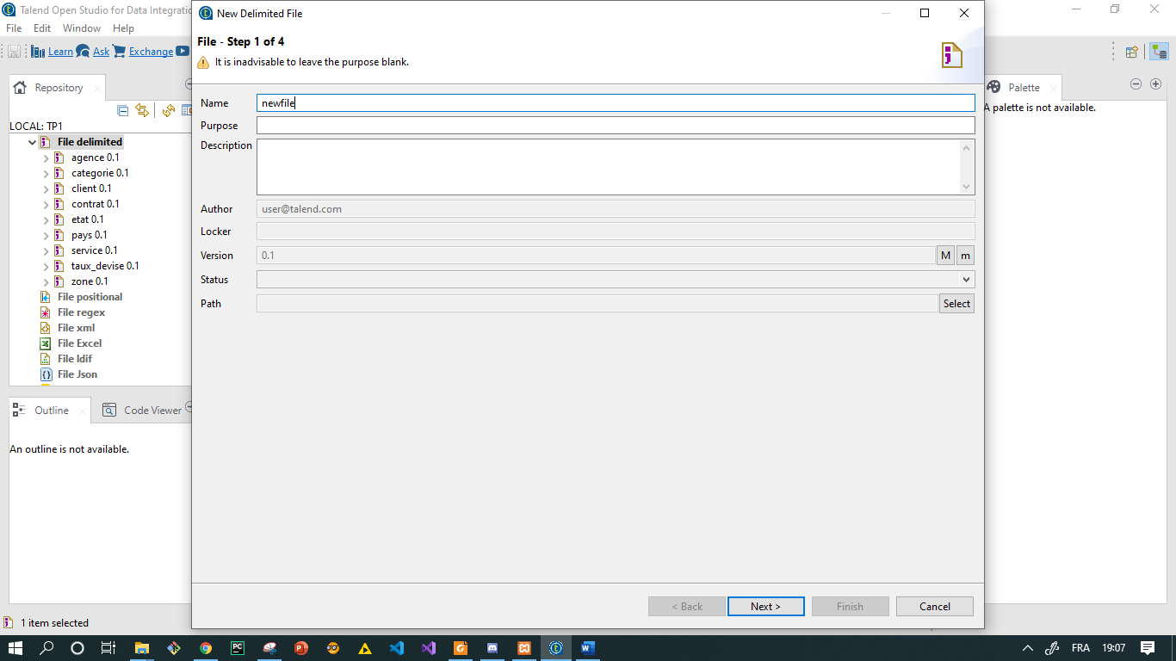

**Créer le connecteur de données à la base:** establish connection with the model in database, when the connection is established we get the message below :

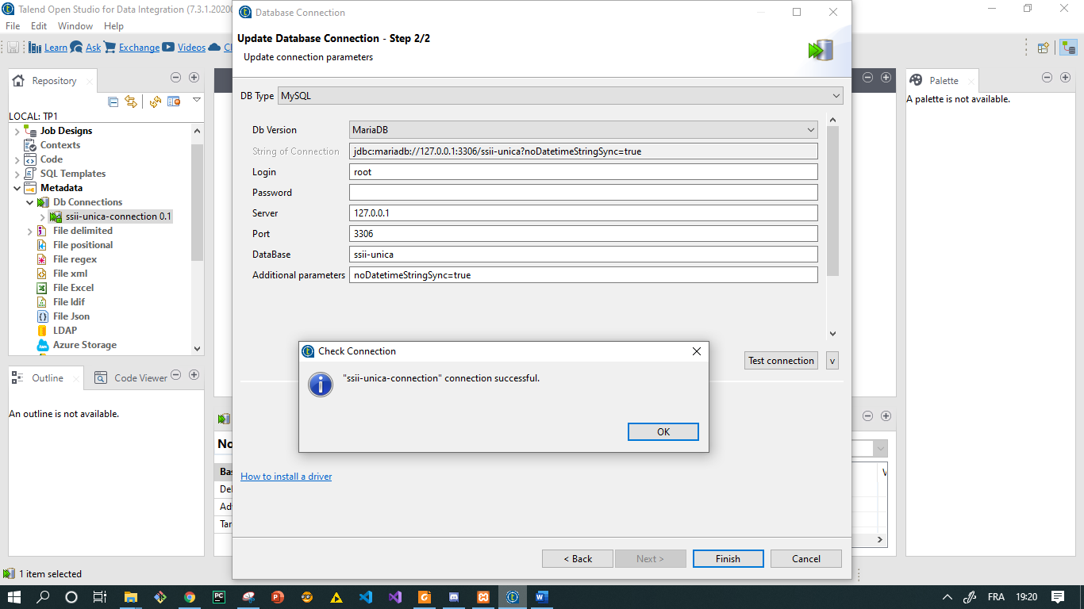

**Créer les métadonnées pour les tables:** create schema for each one of our delimited file, the result will be like the screen below :

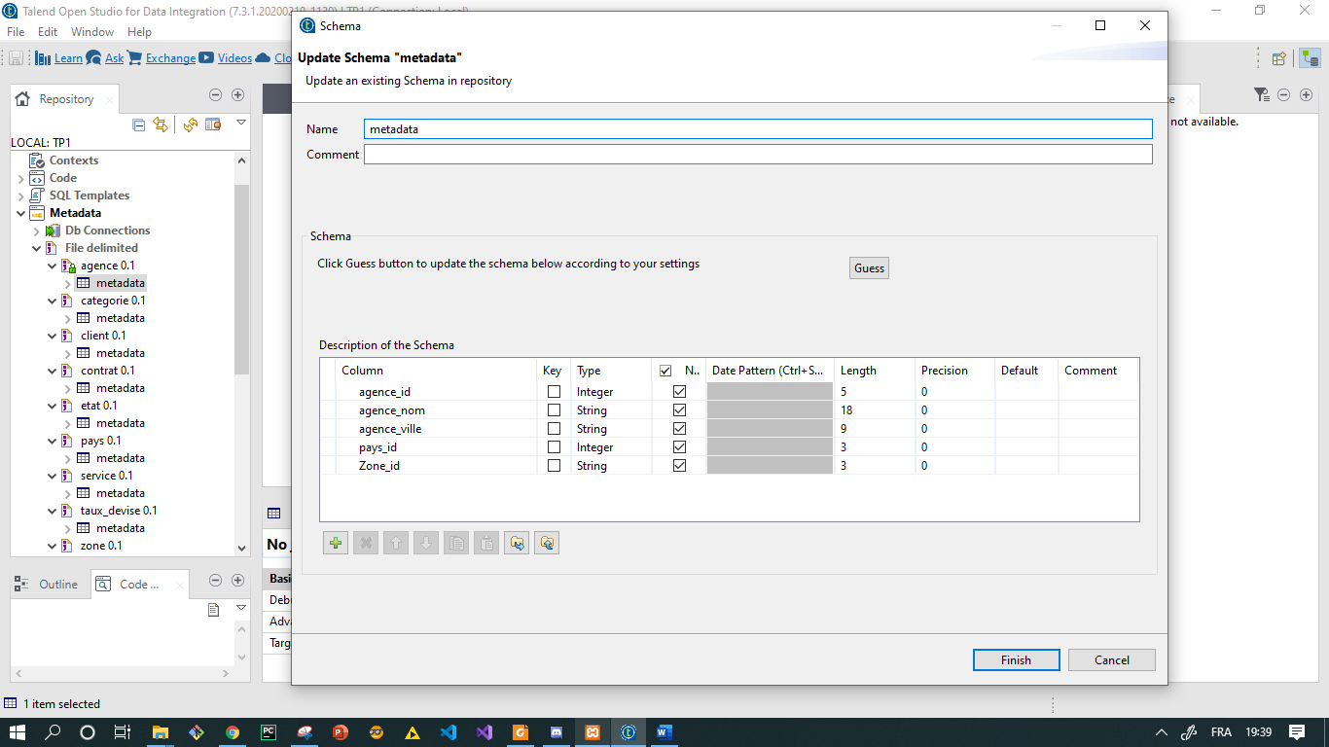

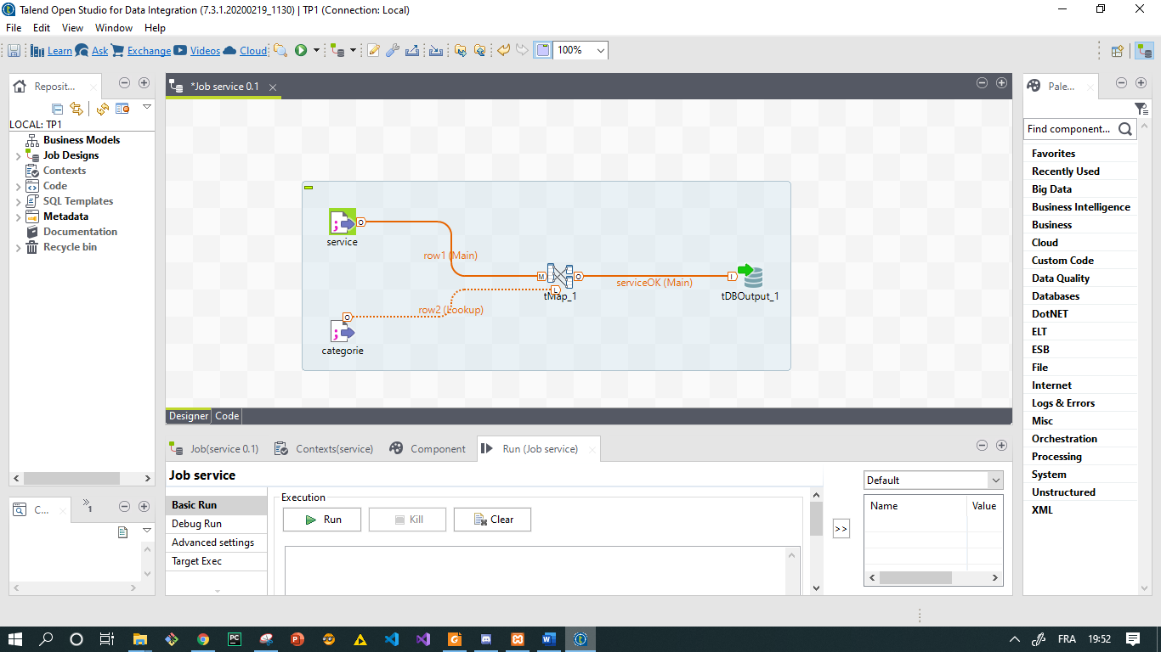**Etape 4 : Création des tables de dimention**   
**Charger la dimension Service en utilisant les fichiers Service et Catégorie :** We create the first job the result will be like :

we configurate the tMap operation as the screen bellow :

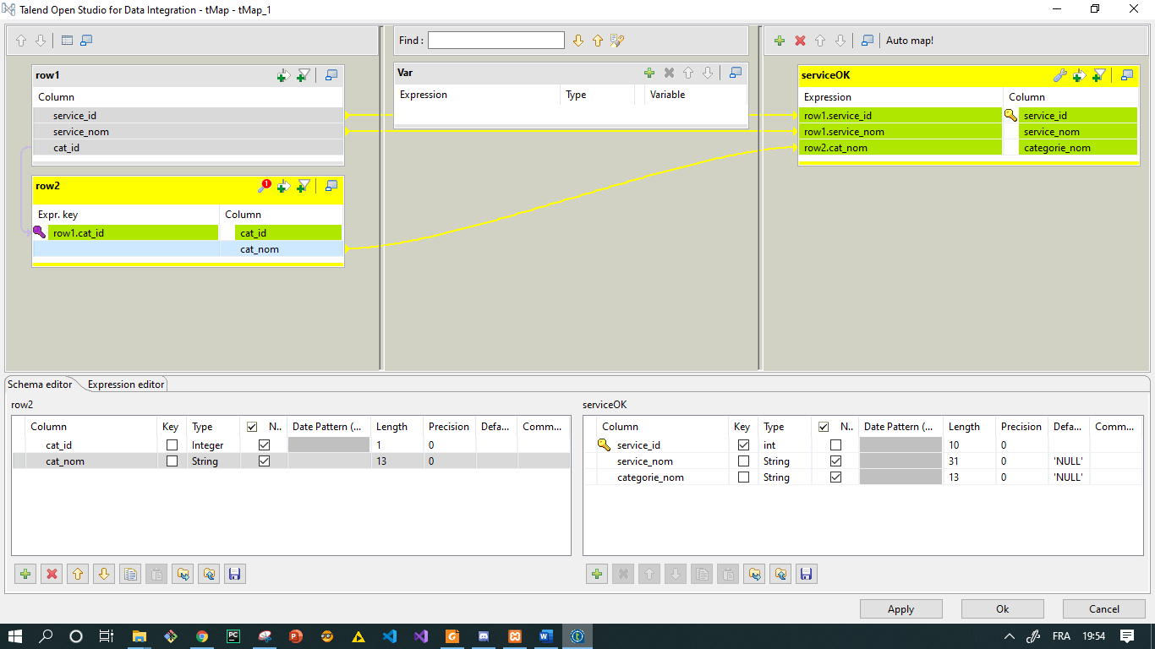

Then we build and run the job and we check the table dimension of the job, the table will be full like the screen below :

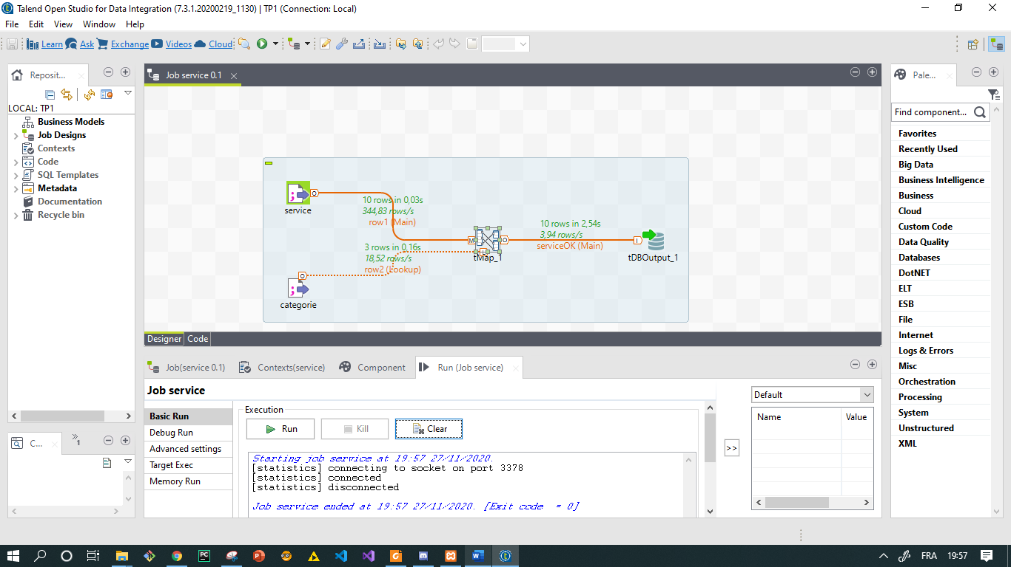

In the server side :

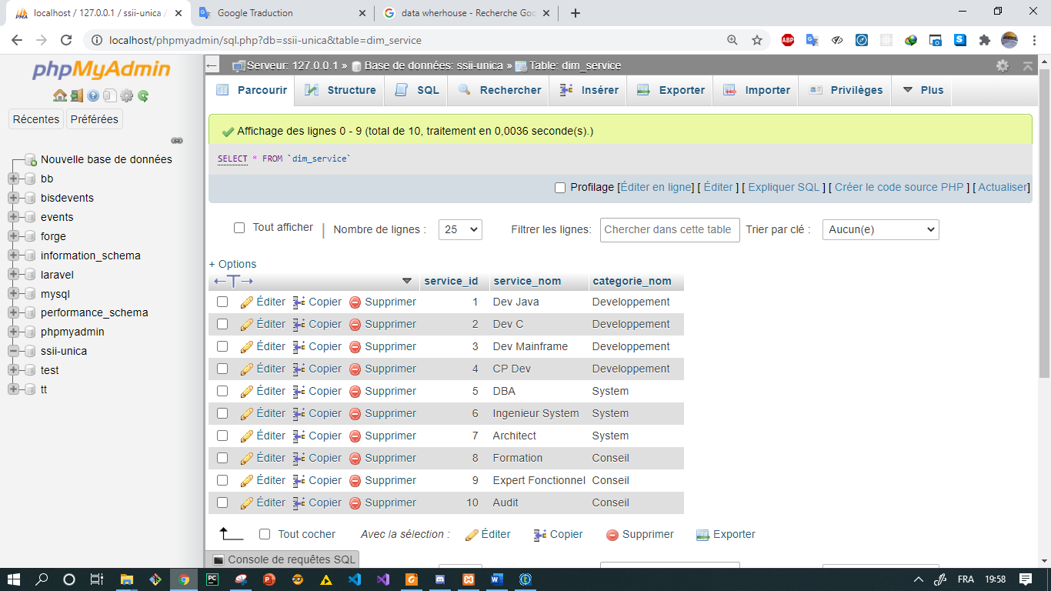

**Charger la dimension Agence en utilisant les fichiers Zone, Pays, Agence:** the job is the result of mapping tree table Agence, Pays, and Zone like the screen below :

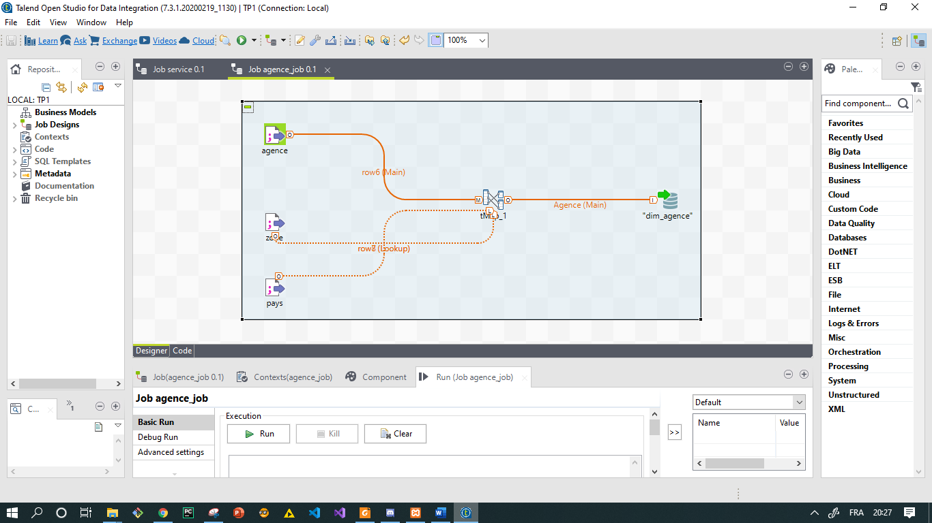

we configurate the tMap operation, The agency attribute will be obtained by concatenating agency name and city agency as show in the screen bellow :

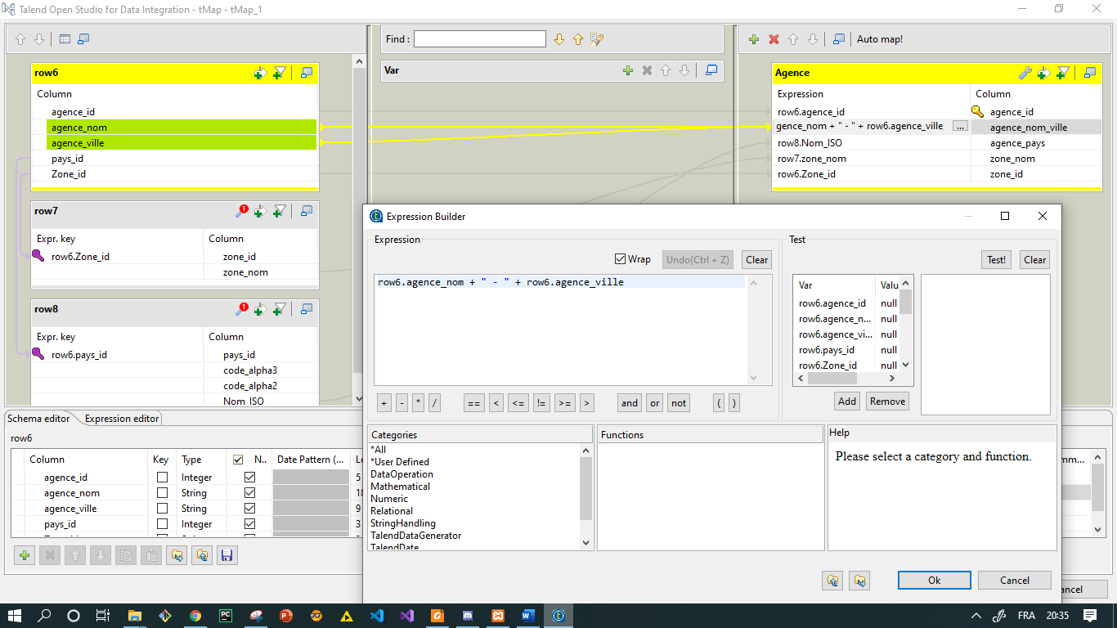

Then we build and run the job and we check the table dimension of the job, the dimension will be full like the screen below :

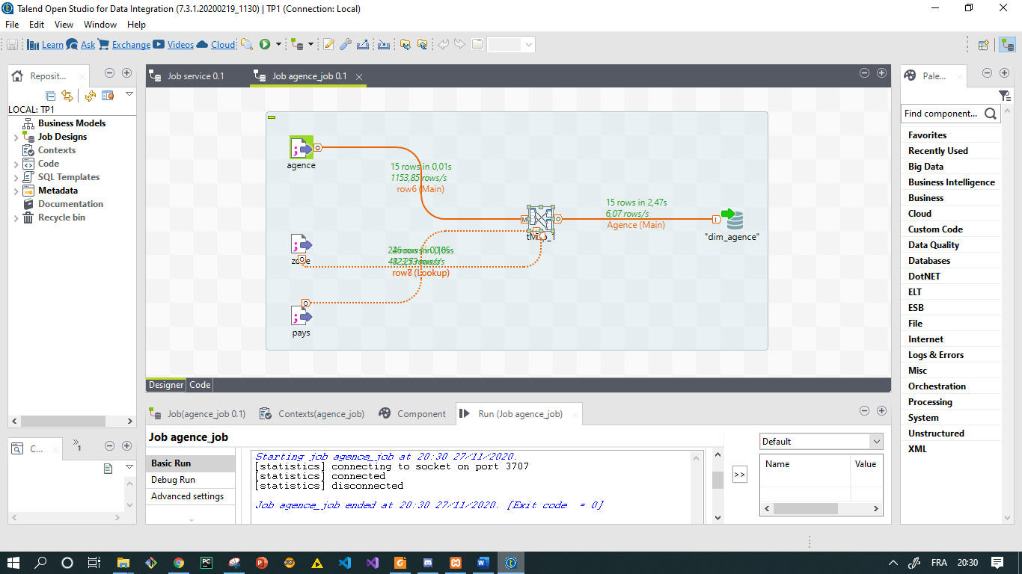

In the server side :

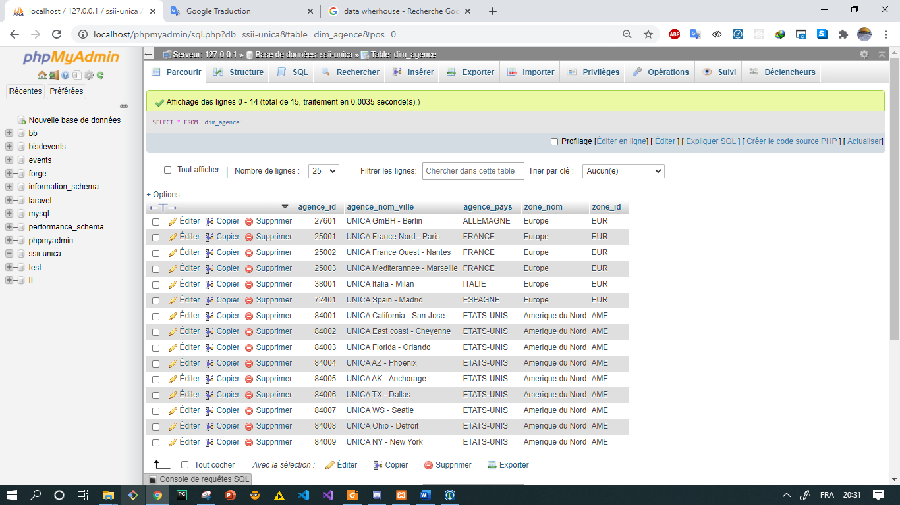

**Charger la dimension Client en utilisant les fichiers Client, Pays et Etat:** the job is the result of mapping tree file: Client, Pays, and Etat like the screen below :

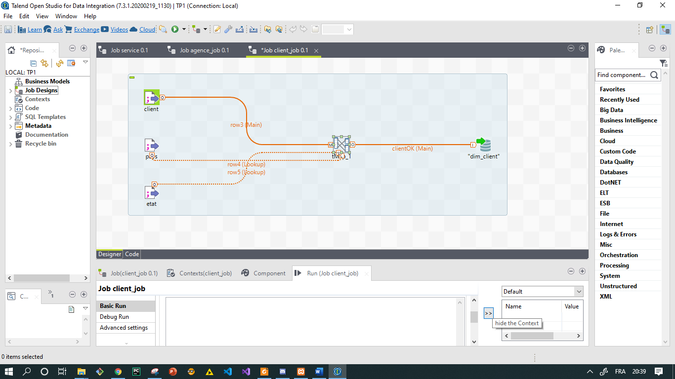

we configurate the tMap operation as the screen bellow :

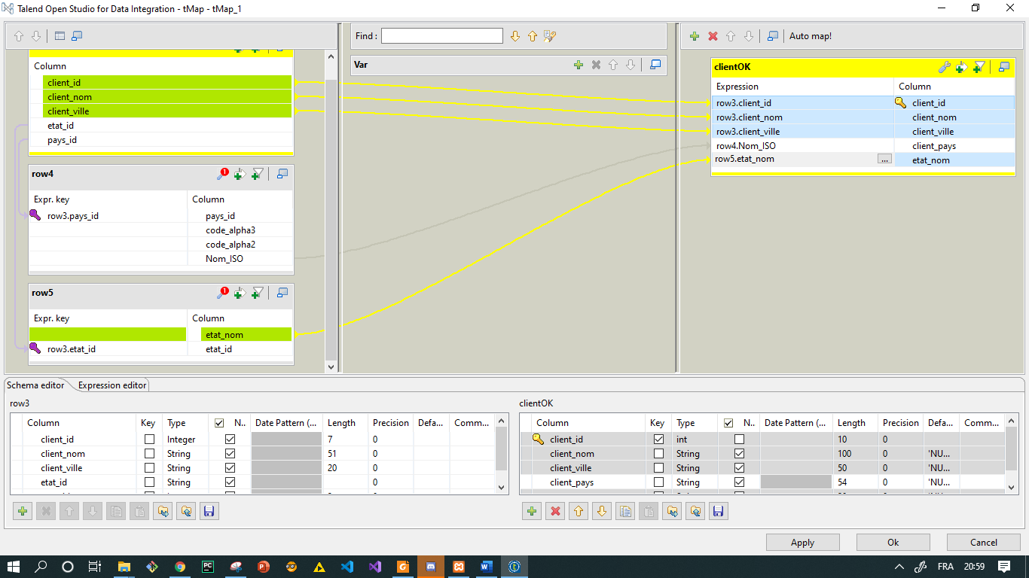

Then we build and run the job and we check the table dimension of the job, the dimension will be full like the screen below :

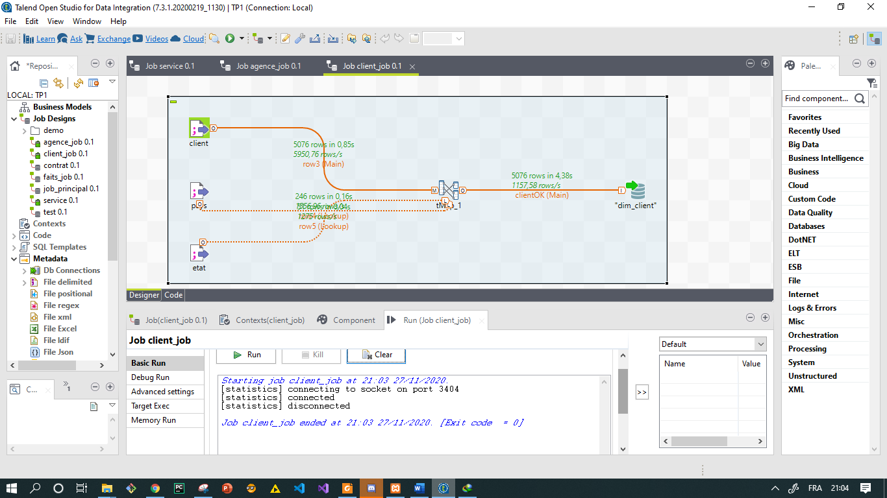

In the server side :

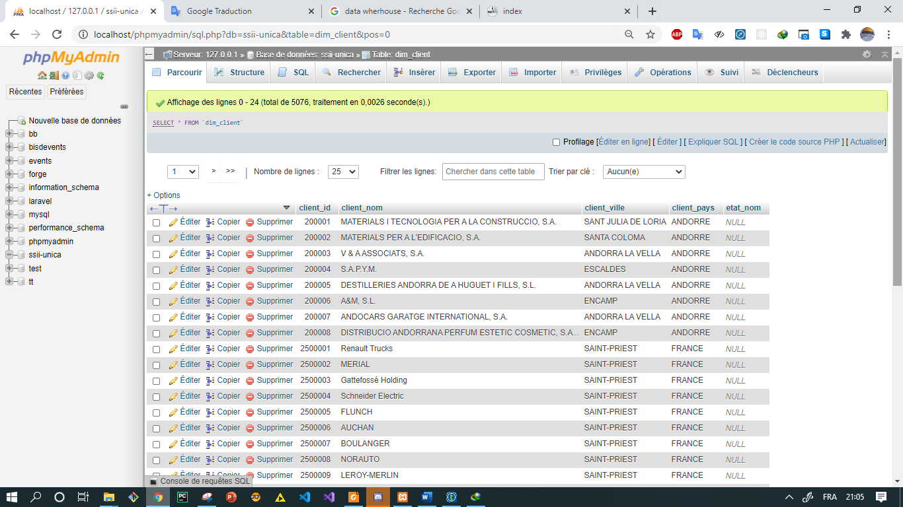

**Charger la dimension Temps à partir des dates de contrats:** in this job we filter the date of contract and we avoid duplicate data then we effected the mapping operation using date as the new key of dimension, the result shown in the screen below :

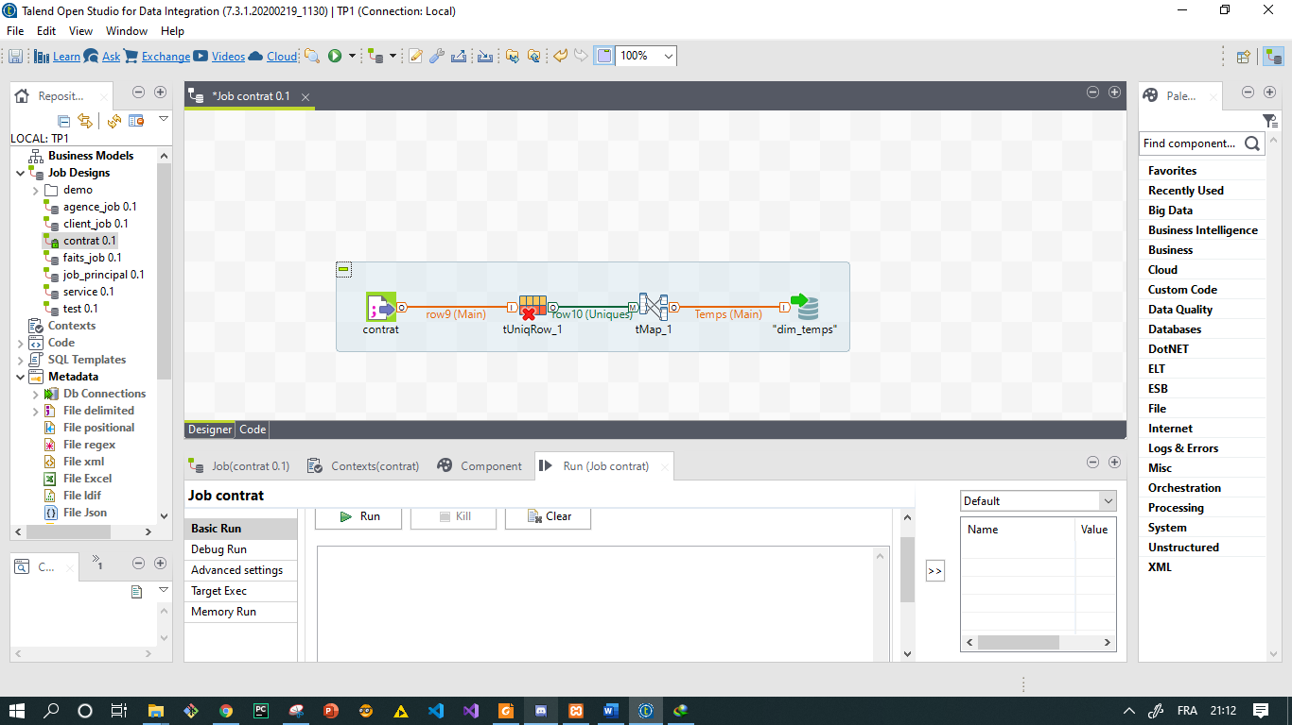

we configurate the tUnique filter to be executed in the primary key “ date contract” then we configurate tMap operation as shown in the screen bellow :

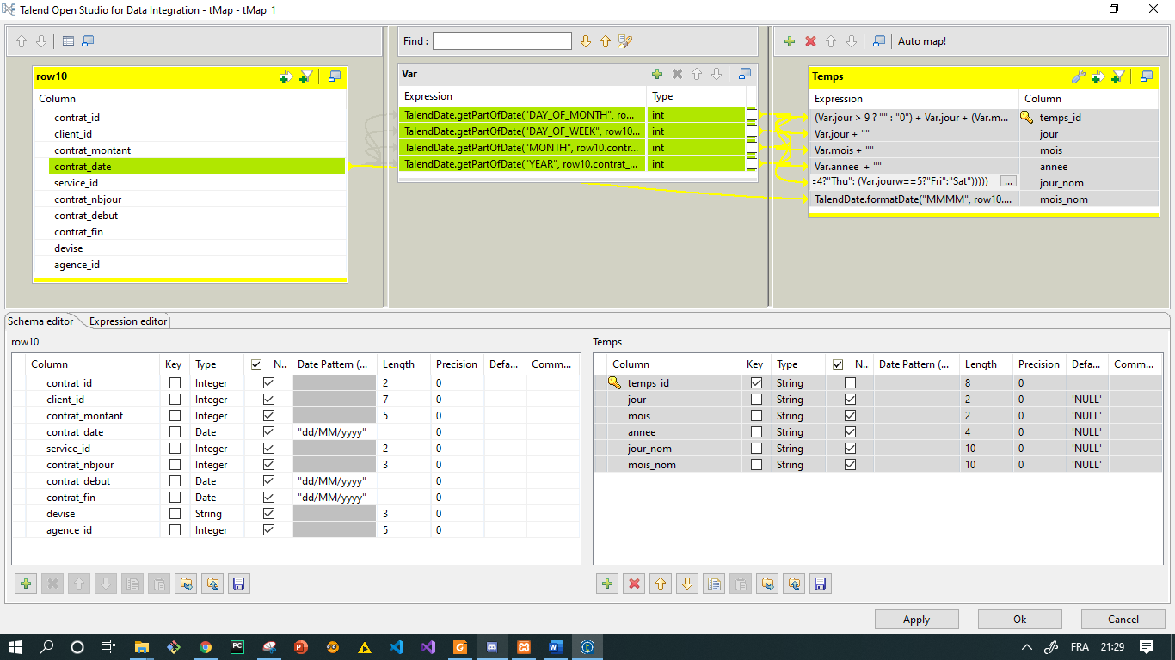

Then we build and run the job and we check the table dimension of the job, the dimension will be full like the screen below :

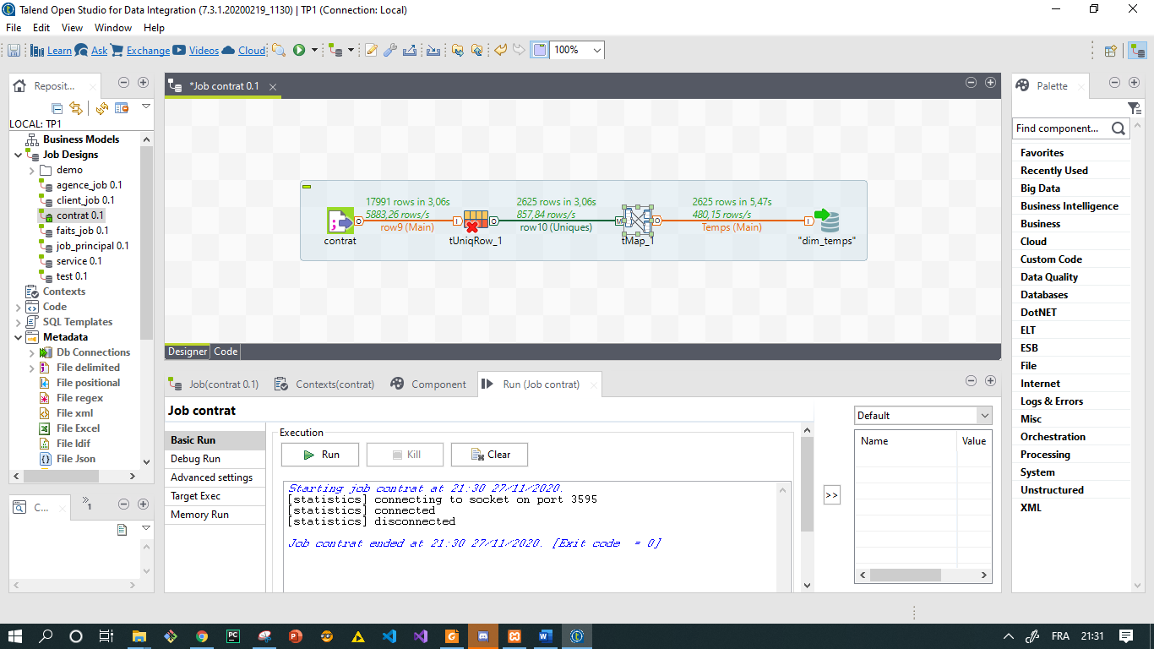here we can see that the number of line is reduced because of unique filter.

In the server side :

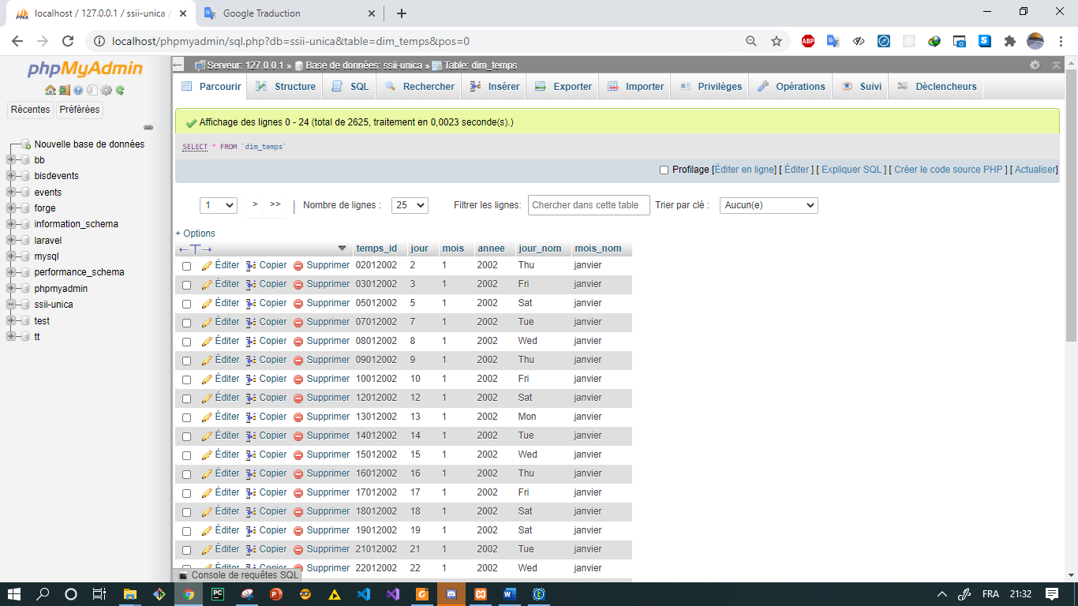

**Etape 5 : Charger les tables faits**

Dans cette étape en fait la remplition de table de faits selon deux démarche :

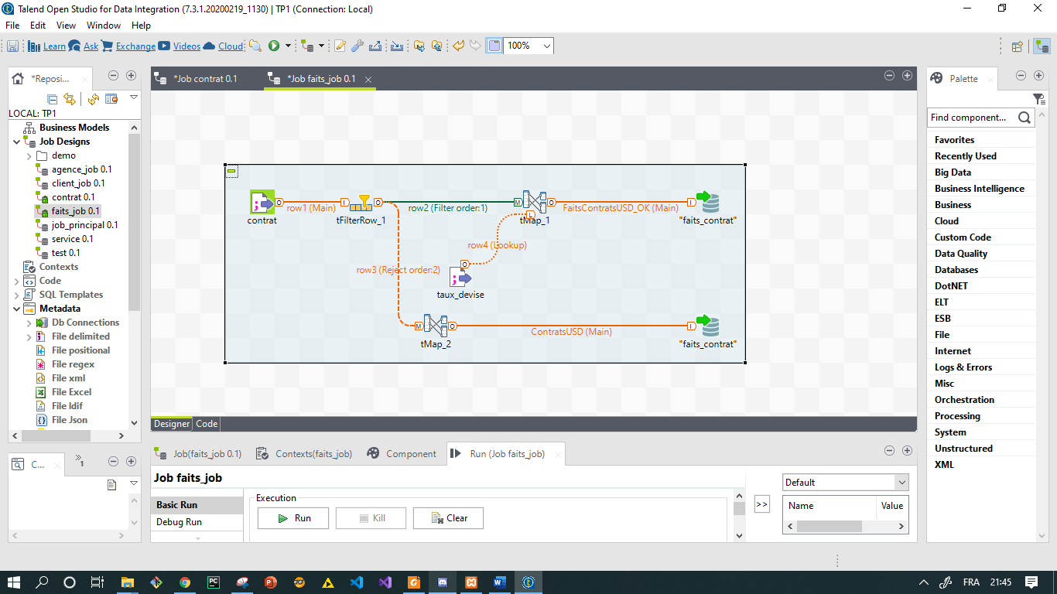

La configuration du filtre et la suivante :

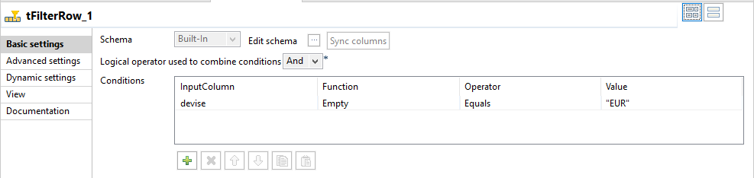

The first mapping (tMap1) configuration is :

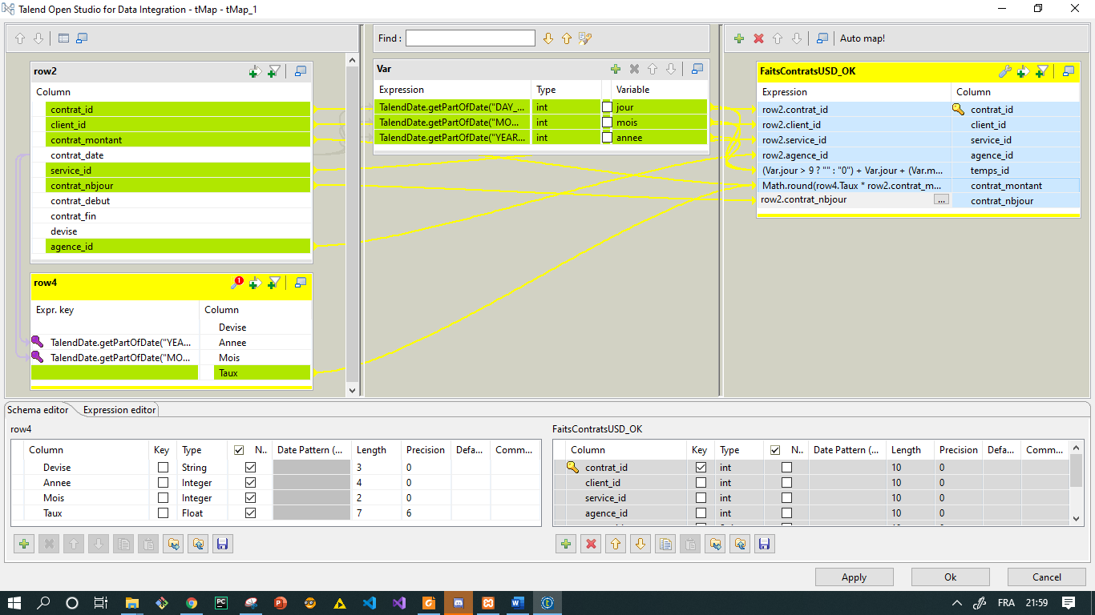

The second mapping (tMap2) configuration is :

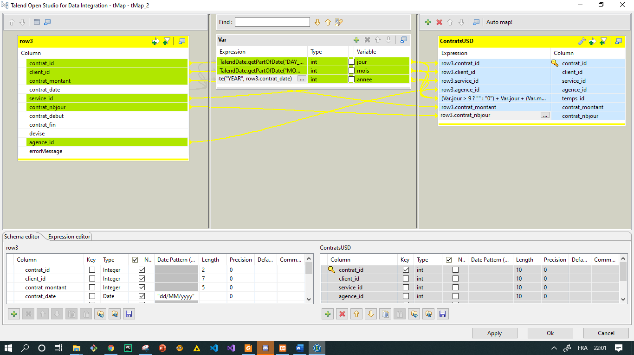

Then we build and run the job we got the result in the screen bellow :

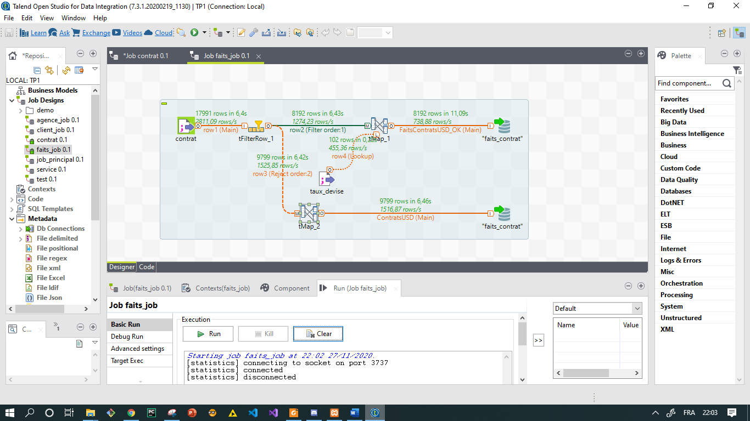

We can constate that the number of rows in the first dim_faits is mince thant the second one , then the importance of the taux device operation

In the server side we have the implementation of table faits

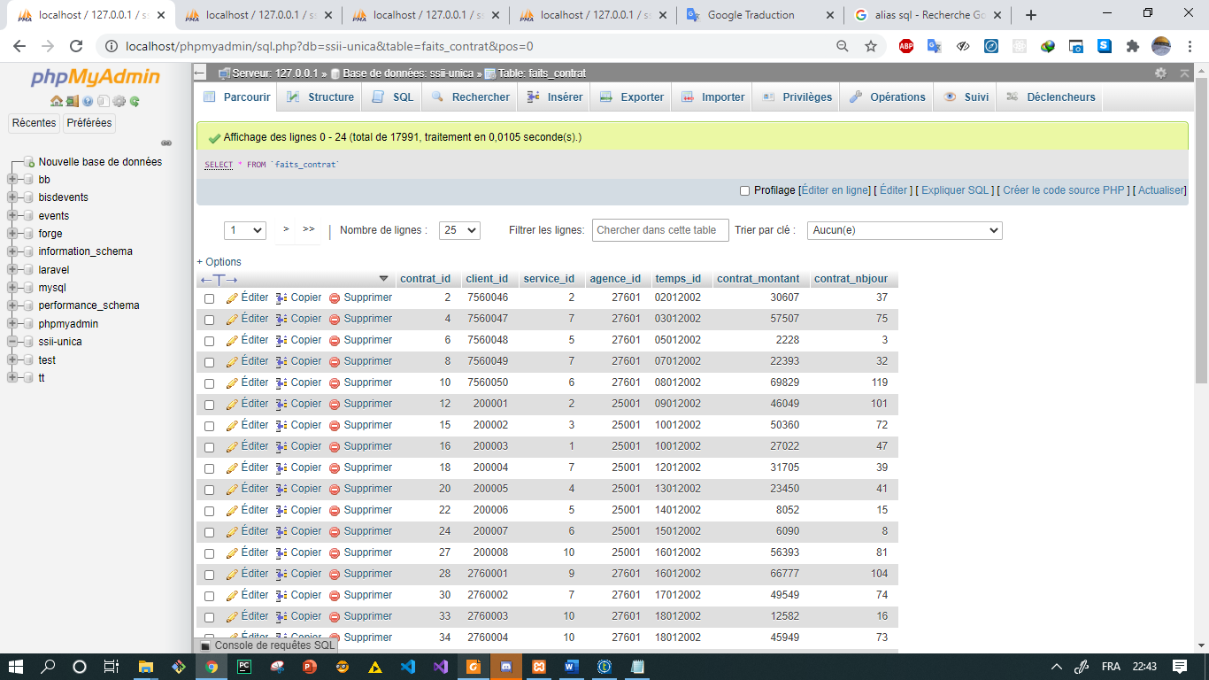

**Etape 6 : Créer un job principal afin d’ordonnancer le chargement des dimensions**

In this step we drag and drop the jobs related with an errors alert then we execute the job , the result is shown in the screens below:

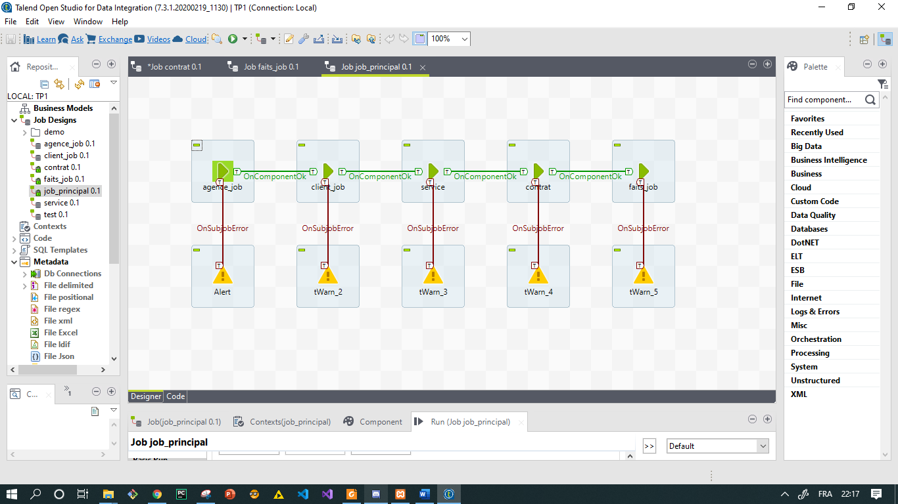

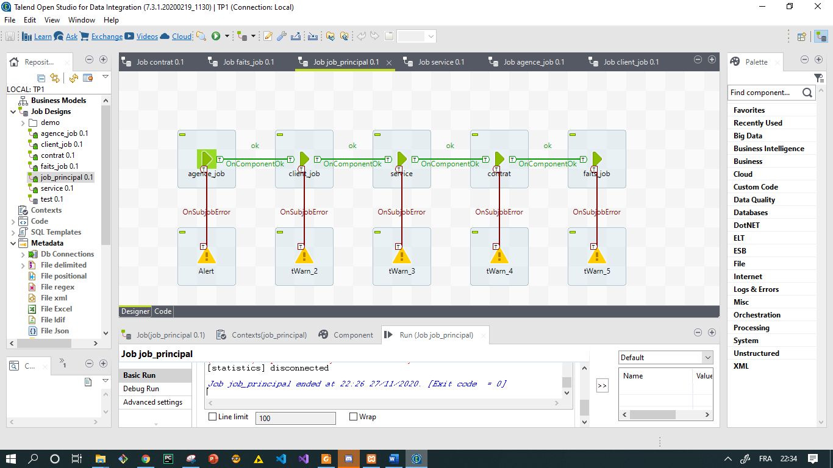

The message is ‘ok’ that’s means all things is good

**Etape 7: Créer un job principal afin d’ordonnancer le chargement des dimensions**

**Query 1 :**

**select** zone_nom, annee, sum(contrat_montant), sum(contrat_nbjour)  
**from** faits_contrat, dim_temps, dim_agence  
**where** faits_contrat.agence_id = dim_agence.agence_id and  
faits_contrat.temps_id = dim_temps.temps_id  
**group by** annee, zone_nom;

**Result  :**

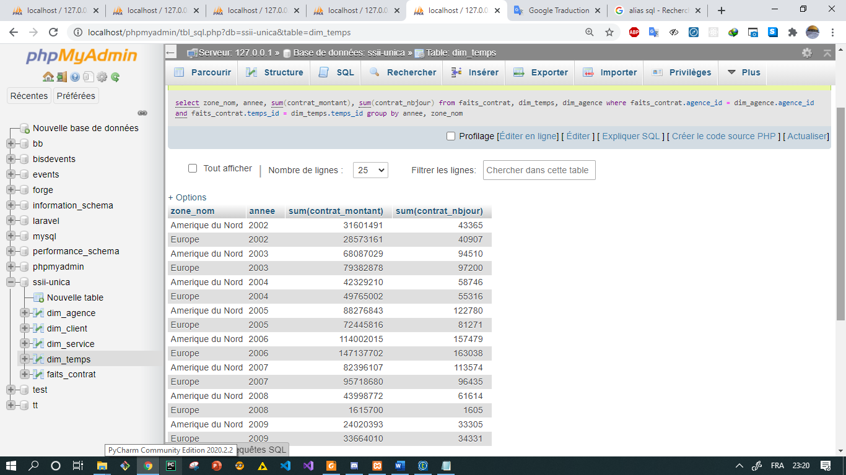

**Query 3 :**

[select](http://localhost/phpmyadmin/url.php?url=https://dev.mysql.com/doc/refman/5.5/en/select.html) client_nom, [sum](http://localhost/phpmyadmin/url.php?url=https://dev.mysql.com/doc/refman/5.5/en/group-by-functions.html#function_sum)(contrat_nbjour),service_nom from faits_contrat, dim_temps, dim_client , dim_service where faits_contrat.client_id = dim_client.client_id [and](http://localhost/phpmyadmin/url.php?url=https://dev.mysql.com/doc/refman/5.5/en/logical-operators.html#operator_and) faits_contrat.temps_id = dim_temps.temps_id [and](http://localhost/phpmyadmin/url.php?url=https://dev.mysql.com/doc/refman/5.5/en/logical-operators.html#operator_and) faits_contrat.service_id = dim_service.service_id [and](http://localhost/phpmyadmin/url.php?url=https://dev.mysql.com/doc/refman/5.5/en/logical-operators.html#operator_and) service_nom='Dev Java' [and](http://localhost/phpmyadmin/url.php?url=https://dev.mysql.com/doc/refman/5.5/en/logical-operators.html#operator_and) annee >= 2006 group by annee ORDER BY service_nom ASC limit 1

**Result  :**

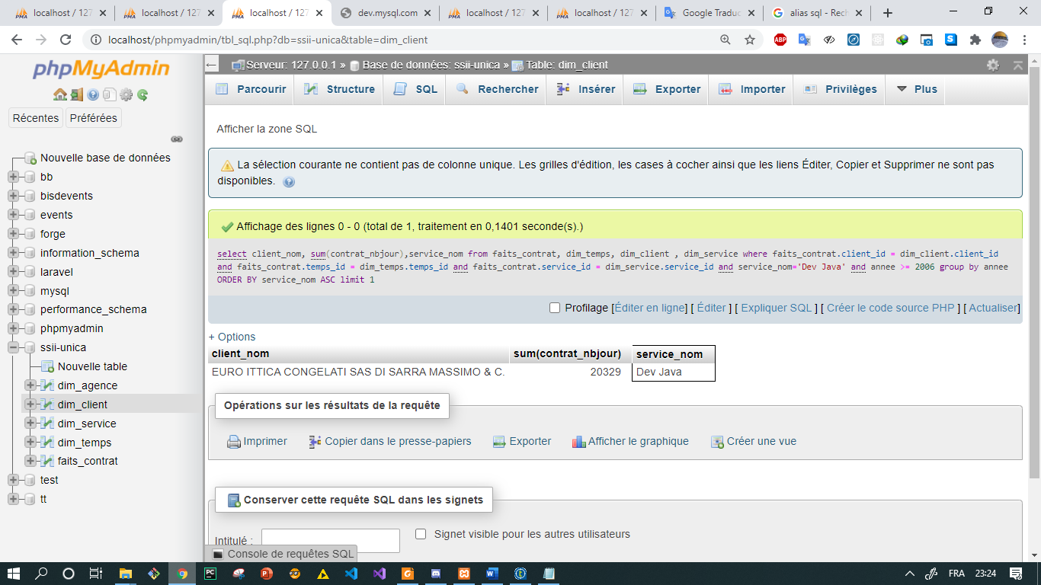

**Query 2 :**

[select](http://localhost/phpmyadmin/url.php?url=https://dev.mysql.com/doc/refman/5.5/en/select.html) [sum](http://localhost/phpmyadmin/url.php?url=https://dev.mysql.com/doc/refman/5.5/en/group-by-functions.html#function_sum)(contrat_montant) from faits_contrat, dim_temps, dim_agence, dim_service where faits_contrat.agence_id = dim_agence.agence_id [and](http://localhost/phpmyadmin/url.php?url=https://dev.mysql.com/doc/refman/5.5/en/logical-operators.html#operator_and) faits_contrat.temps_id = dim_temps.temps_id [and](http://localhost/phpmyadmin/url.php?url=https://dev.mysql.com/doc/refman/5.5/en/logical-operators.html#operator_and) faits_contrat.service_id = dim_service.service_id [and](http://localhost/phpmyadmin/url.php?url=https://dev.mysql.com/doc/refman/5.5/en/logical-operators.html#operator_and) dim_agence.agence_pays = 'FRANCE' [and](http://localhost/phpmyadmin/url.php?url=https://dev.mysql.com/doc/refman/5.5/en/logical-operators.html#operator_and) dim_service.categorie_nom = 'Conseil' [and](http://localhost/phpmyadmin/url.php?url=https://dev.mysql.com/doc/refman/5.5/en/logical-operators.html#operator_and) dim_temps.annee = 2008

**Result  :**

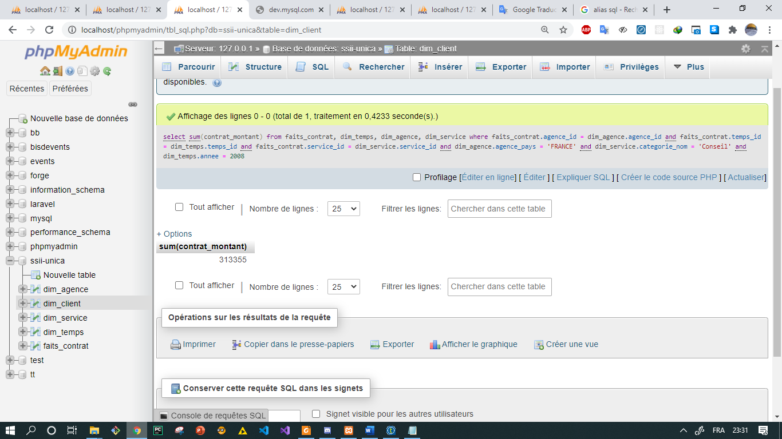

**----- the end**

**It was a great experience to discover Talend, I enjoy it and I learn a lot ^^**